**Superior University Reiwend Road**

.

Name: Haseeb Arshad

Roll no: SU92–BSSEM-F22-177

Section:5D

Subject: CN Lab  
Task 7

Submitted to: Sir Rasikh Ali

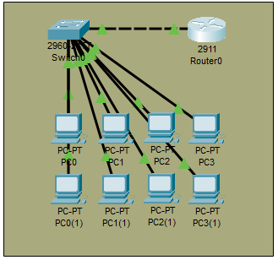

**Router Configuration:**

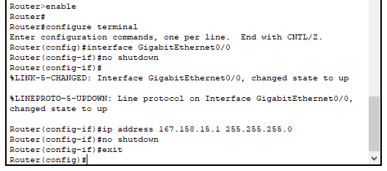

**Enable DHCP on router:**

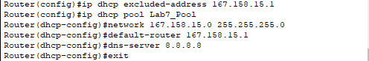

**Testing the Network:**

